How to boot CENTOS 7 Using UEFI

Results Analysis
Version 0.9

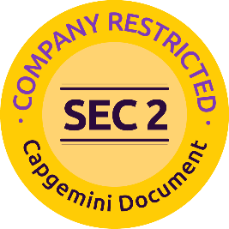

Customer Restricted - Information that is intended for a restricted set of employees with the right / need to know principle relating to a specific Account engagement where information owned by the client but managed by Capgemini or information related to customers and their environments (both Technology and Business related) is being handled. This classification must be used for Capgemini documentation and systems where information is being shared with the client.

Editing
Verification
Validation

Monitoring developments
Version | Date | Editor | Description
V0.9 | 31-11-2024 | Capgemini Engineering Team | Results analysis, draft version.
Table 1: Change history

Distribution
Name | Function | Organization
EXFO Engineering Team | Engineering | EXFO
CG Engineering Team | Engineering | Capgemini
Table 2: Distribution list

Content
1 Introduction 4
1.1 Purpose of the document 4
1.2 Scope 4
1.3 References 4
2 check secure Boot status 5
2.1 Write your own MOK keys 5
2.2 To convert MOK.priv to pem use below command 5
3 Signing Keys 6
3.1 Sign your own grub/kernel/shim/ using MOK.pem 6
4 Dependencies 7
4.1 Install sbsign and efi tools: 7
5 Importing MOK Keys 9
5.1 Import the MOK key 9
6 Untar the kernel Module 11
7 Enable Secure Boot 13
8 Verify Secure Boot status 14
9 Stakeholder 15

Introduction

Purpose of the document
The purpose of this document is to provide a step-by-step guide to manage Secure Boot on a CentOS 7 system. It covers creating and signing your own Machine Owner Key (MOK) certificates, signing GRUB, kernel, and shim for Secure Boot, and verifying the setup.

Scope
The document outlines the process to configure, enable, and verify Secure Boot with custom MOK certificates on a CentOS 7 system.

References
- https://lists.centos.org/hyperkitty/list/announce@lists.centos.org/thread/2APH7YUSNGVRJD5LAXBI46BBB5AKWHZZ/
- https://vault.centos.org/7.9.2009/
- How to boot Linux using UEFI with Secure Boot ? — Get Intimate With Cyber ! 0.1 documentation
- https://access.redhat.com/solutions/10154
- https://www.linuxquestions.org/questions/linux-newbie-8/create-iso-from-centos-7-server-4175653114/#google_vignette
- https://www.linuxquestions.org/questions/linux-newbie-8/create-iso-from-centos-7-server-4175653114/#google_vignette

check secure Boot status
1.To check the current Secure Boot status
mokutil –sb-state
2.Edit the Base URLs in CentOS-Base.repo
vi /etc/yum.repos.d/CentOS-Base.repo
Comment out all mirror URLs by adding a # at the beginning of each line containing mirrorlist.
Add the following baseurl lines under the respective sections:
Under [base]:
baseurl=http://vault.centos.org/7.9.2009/os/$basearch/
Under [updates]:
baseurl=http://vault.centos.org/7.9.2009/updates/$basearch/
Under [extras]:
baseurl=http://vault.centos.org/7.9.2009/extras/$basearch/
Save and exit the file:
Press Esc, then type :wq and hit Enter.
NOTE:Initially, Secure Boot must be under Disabled State.

Write your own MOK keys
To generate your own MOK certificates, use the following command:
openssl req -new -x509 -newkey rsa:2048 -keyout MOK.priv -out MOK.der -nodes -days 365 -subj "/CN=Custom MOK Key/”
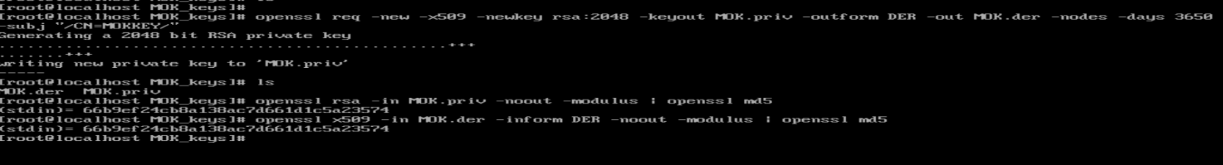
MOK.der and MOK.priv wil be created.

To convert MOK.priv to pem use below command
openssl req -new -x509 -key MOK.priv -out MOK.pem -days 365
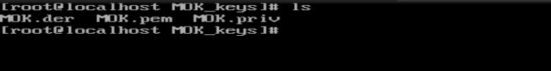

Signing Keys
Below procedure to be followed for signing the keys

Sign your own grub/kernel/shim/ using MOK.pem
To sign shim:
sbsign–key MOK.priv –cert MOK.pem –output /boot/efi/EFI/centos/shimx64.efi.signed /boot/efi/EFI/centos/shimx64.efi
To sign grub:
sbsign --key MOK.priv --cert MOK.pem --output /boot/efi/EFI/centos/grubx64.efi.signed /boot/efi/EFI/centos/grubx64.efi
To sign kernel:
sbsign --key MOK.priv --cert MOK.pem --output /boot/vmlinuz-$(uname-r).signed /boot/vmlinuz-$(uname-r)

Dependencies
Install the following tools:
- sbsign tools
- efitools
- kernel source

Install sbsign and efi tools:
To install the required tools, follow these steps:
Get the tar file from
http://10.16.128.175/Dependencies.tar.gz
http://10.16.128.175/dep_1.tar.gz
Extract the contents of dep_1tar.gz into the /home/exfo directory:
- tar -zxvf dep_1.tar.gz -C /home/exfo
Inside the extracted files, locate directories openssl, devtool,elfutil,git,m4
Install the rpm packages
- rpm -i *.rpm
Extract the contents of Dependencies.tar.gz into the /home/exfo directory:
- tar -zxvf Dependencies.tar.gz -C /home/exfo
Inside the extracted files, locate and extract depSbsign.tar.gz:
- tar -zxvf depSbsign.tar.gz
Install the RPM packages from the extracted depSbsign directory:
- rpm -i *.rpm
Next, extract depEfiTools.tar.gz:
- tar -zxvf depEfiTools.tar.gz
Install the RPM packages from the extracted depEfiTools directory:
- rpm -i *.rpm
Extract the contents of Tools.tar.gz:
- tar -zxvf Tools.tar.gz
Navigate to the sec-os directory:
- cd sec-os
Install sbsigntools:
  - cd sbsigntools
  - ./autogen.sh
  - ./configure
  - make check
  - make install
  - make install check

Install efitools:
  - cd ../efitools
  - make
  - make install
NOTE: The installation must be successfully completed at each step without any error messages

Importing MOK Keys

Import the MOK key
1.Run following command to import the keys:
mokutil –import /path/to/MOK.der
It prompts the password Twice, Provide same password both times.
2.Reboot the system and follow on-screen instructions to enroll the MOK keys
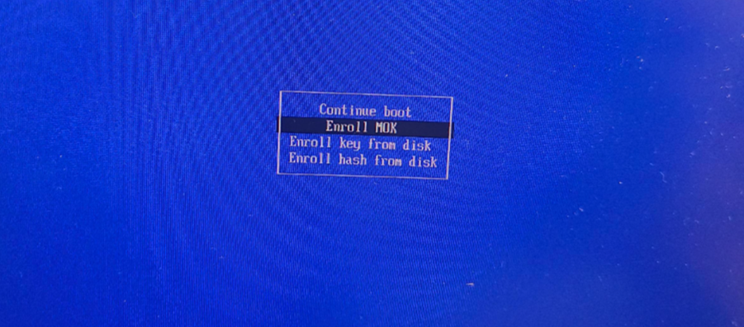

3. provide the password you have created during MOK key importing

4. Reboot
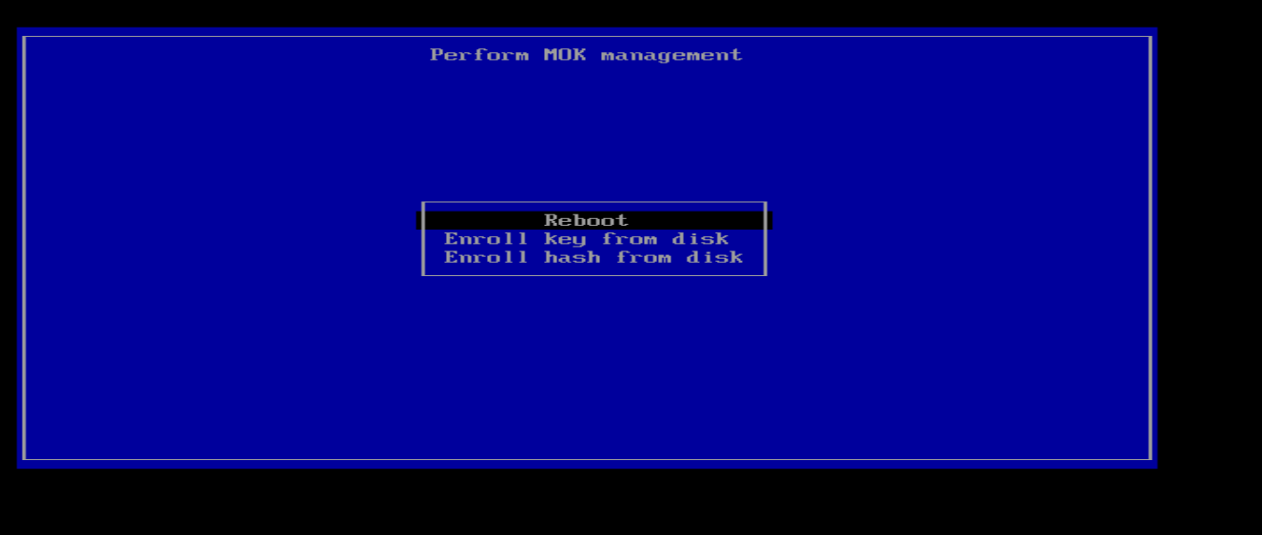

6 Untar the kernel Module
Get these files on the server if they are not on the USB key
http://10.16.128.175/racer_0x1000_0x2412_0x0001.bit
http://10.16.128.175/racer_0x1002_0x2412_0x0001.bit
2.Extract the contents of Dependencies.tar.gz into the /home/exfo directory:
- tar -zxvf Dependencies.tar.gz -C /home/exfo
Inside the extracted files, locate and extract lastmile.tar.gz:
- tar -zxvf lastmile.tar.gz
3. Build and load the lastmile driver:
cd lastmile/driver
make
4.Here lastmile.ko gets generated. Sign this .ko using MOK keys by following below steps
Untar the keys.tar.gz
sudo /usr/src/kernels/$(uname -r)/scripts/sign-filesha256 /home/exfo/home/admin/mok_keys/MOK.priv /home/exfo/home/admin/mok_keys/MOK.der /home/exfo/lastmile/driver/lastmile.ko
sudo ./load_driver.sh
5.Build the rawcardtool utility:
cd ../rawcardtool
6.make
7.Verify that everything was successful so far
/rawcardtool –status
8. You should see similar output to this:
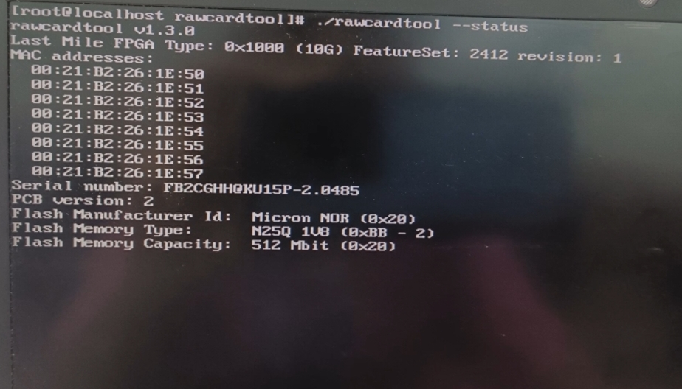

Enable Secure Boot
To Enable Secure Boot
Enter into BIOS/UEFI menu by pressing F9. Enable Secure Boot under the system utilities in ILO6

Verify Secure Boot status
To confirm Secure Boot is Enabled, Run below command
mokutil --sb-state

Stakeholder

Name | Function | Title
Kesavan,Nivetha | Project Manager | Project Manager
Vijayan Bharathi | Delivery Manager | Director
Suresh Kalidasan | Architect | Architect
Navyasree | Software Developer | Engineer
Jhansi Vaddipalli | Software Developer | Engineer

About Capgemini Engineering
Capgemini Engineering combines, under one brand, a unique set of strengths from across the Capgemini Group: the world leading engineering and R&D services of Altran – acquired by Capgemini in 2020 - and Capgemini’s digital manufacturing expertise. With broad industry knowledge and cutting-edge technologies in digital and software, Capgemini Engineering supports the convergence of the physical and digital worlds. Combined with the capabilities of the rest of the Group, it helps clients to accelerate their journey towards Intelligent Industry. Capgemini Engineering has more than 52,000 engineer and scientist team members in over 30 countries across sectors including aeronautics, automotive, railways, communications, energy, life sciences, semiconductors, software & internet, space & defence, and consumer products.
Capgemini Engineering is an integral part of the Capgemini Group, a global leader in partnering with companies to transform and manage their business by harnessing the power of technology. The Group is guided every day by its purpose of unleashing human energy through technology for an inclusive and sustainable future. It is a responsible and diverse organization of 270,000 team members in nearly 50 countries. With its strong 50-year heritage and deep industry expertise, Capgemini is trusted by its clients to address the entire breadth of their business needs, from strategy and design to operations, fueled by the fast evolving and innovative world of cloud, data, AI, connectivity, software, digital engineering and platforms. The Group reported in 2020 global revenues of €16 billion.
Get the Future You Want | www.capgemini.com





This document contains information that may be privileged
or confidential and is the property of the Capgemini Group.
Copyright © 2022 Capgemini. All rights reserved.

